A000-Xian-Ring-Fish-[ἰχθύς](https://en.wiktionary.org/wiki/%E1%BC%B0%CF%87%CE%B8%CF%8D%CF%82)-100 CE

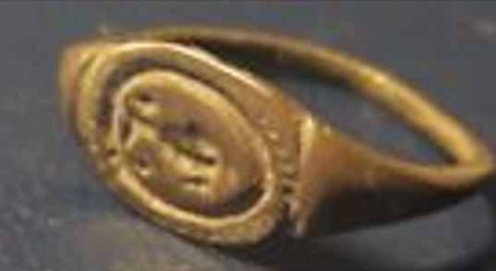 

**Case No.: 4**

**Accession No.**

**Formal Label:** Xian-Ring-Fish-[ἰχθύς](https://en.wiktionary.org/wiki/%E1%BC%B0%CF%87%CE%B8%CF%8D%CF%82)-100 CE

**Display Description:**

[ἰχθύς](https://en.wiktionary.org/wiki/%E1%BC%B0%CF%87%CE%B8%CF%8D%CF%82) 1st cent. CE Koine Greek "fish" is an acronym for  "Ἰησοῦς Χριστός, Θεοῦ Υἱός, Σωτήρ" (*Iēsous Christos, Theou Yios, Sōtēr*;  Jesus Christ, Son of God, Savior'.. The symbol iusually consists of two intersecting arcs, the ends of the right side extending beyond the meeting point so as to resemble the profile of a fish. This was a clandestine symbol to avert persecution by Roman authorities and to identify other Believers.

**LC Classification:**

**Date or Time Horizon: 100 AD**

**Geographical Area: Eastern Mediterranean**

**Map:**

**GPS coordinates:**

**Cultural Affiliation: Early Church**

**Medium: bronze**

**Dimensions:**

**Weight:**

**Condition: original**

**Provenance:**

**Discussion:**

**References:**

 Rasimus, T. (2011). "Revisiting the Ichthys: A Suggestion Concerning the Origins of Christological Fish Symbolism". Pp 327-348 in *Mystery and Secrecy in the Nag Hammadi Collection and Other Ancient Literature: Ideas and Practices.* Biblical Studies, Ancient Near East and Early Christianity E-Books Online, Collection 2012, **76**.

Jowett, Garth S.; O'Donnell, Victoria (11 March 2014). *Propaganda & Persuasion*. SAGE Publications. p. 86.  Initially used as a secret sign during the time when Christians were persecuted by the Roman authorities, the fish symbolized the mission of the group it represented and did so simply and effectively.

**APPENDIX**: Order Hidden

|  |  |
| --- | --- |
| ORDER DATE  May 12, 2018 | ORDER TOTAL  US $59.23  **Order roman silver ring depicting a fish on the bezel**[View similar items](http://www.ebay.com/sch/sis.html?_nkw=roman+silver++ring+depicting+a+fish+on+the+bezel&_id=162930918140&&_trksid=p2057872.m2749.l2658)[View seller's other items](http://www.ebay.com/sch/romantiquity/m.html?ssPageName=&_trksid=p2057872.m2749.l2654)  [More actions](https://www.ebay.com/myb/PurchaseHistory) |

1 item sold by [romantiquity](http://www.ebay.com/usr/romantiquity?_trksid=p2057872.m2749.l2754" \o "romantiquity user ID, click for member’s profile)

|  |  |
| --- | --- |
| roman silver ring depicting a fish on the bezel  ( 162930918140 )  [Add note](javascript:;) | ITEM PRICE:  US $59.23 |